1. Find the number of stores in each country.

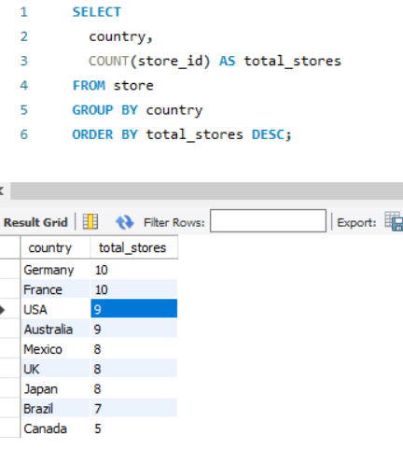

1. Calculate the total number of units sold by each store.

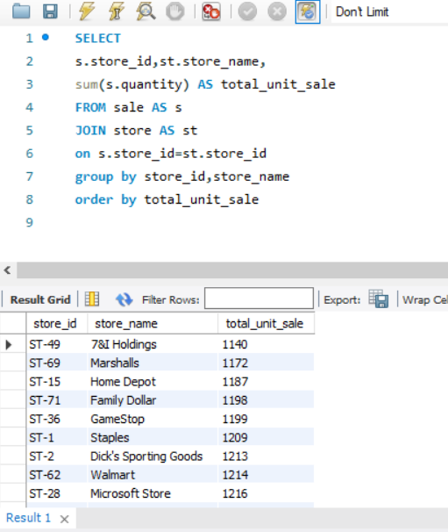

1. Identify how many sales occurred in December 2023?

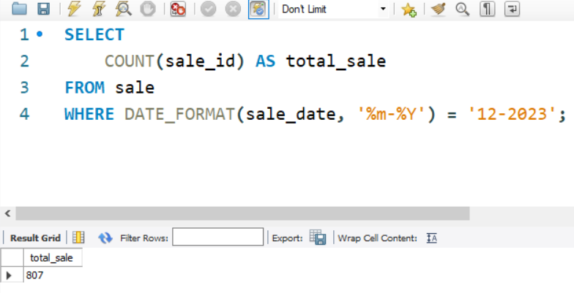

1. Determine how many stores have never had a warranty claim filed.

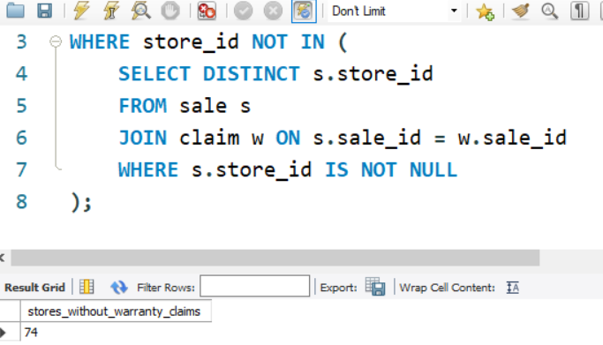

1. Calculate the percentage of warranty claims marked as "rejected".

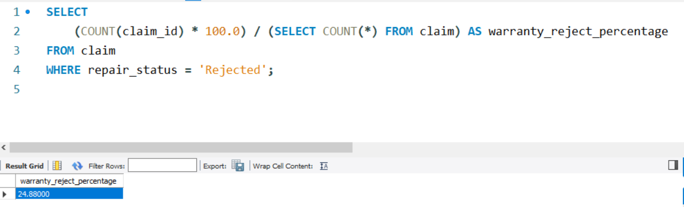

1. Identify which store had the highest total units sold in the last 2 year.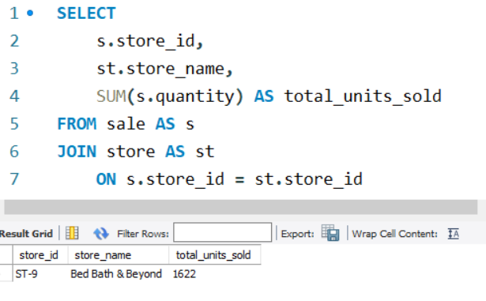

7.Count the number of unique products sold in the last 2 year?

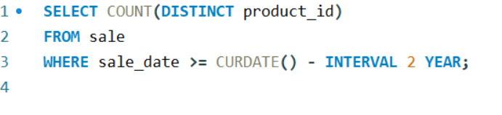

8.Find the average price of products in each category.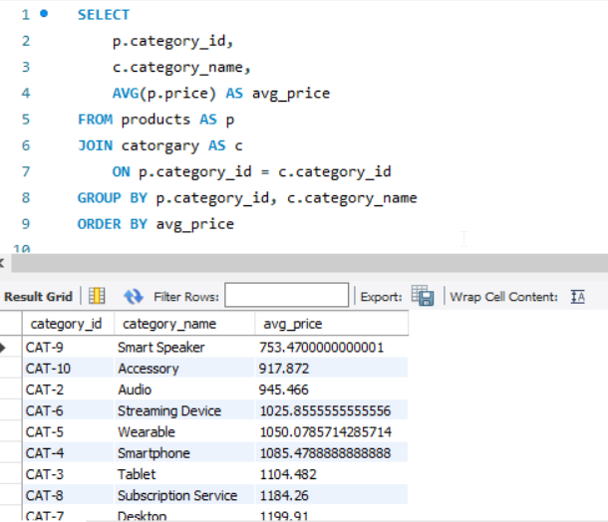

9. How many warranty claims were filed in 2020?

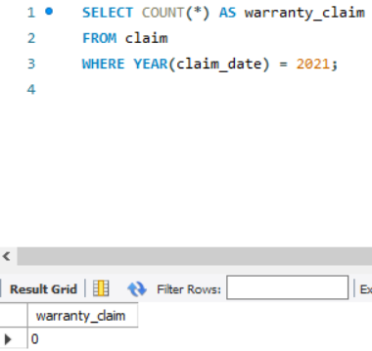

10. For each store, identify the best-selling day based on highest quantity sold.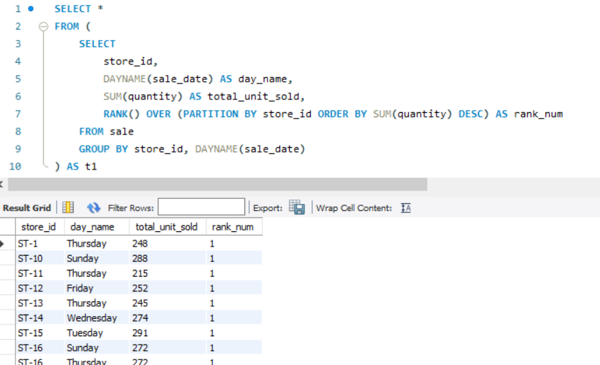

11. Identify the least selling product in each country for each year based on total units sold.

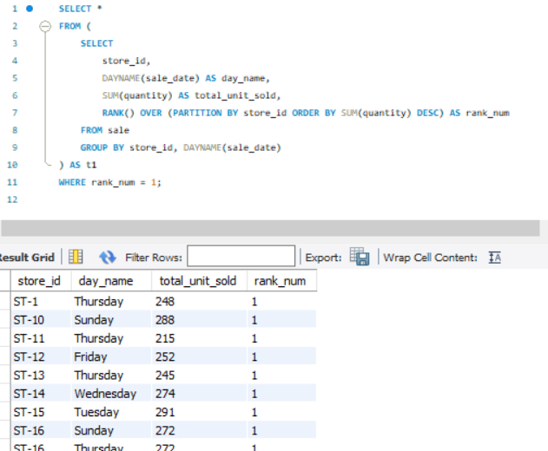

12. Calculate how many warranty claims were filed within 180 days of a product sale.

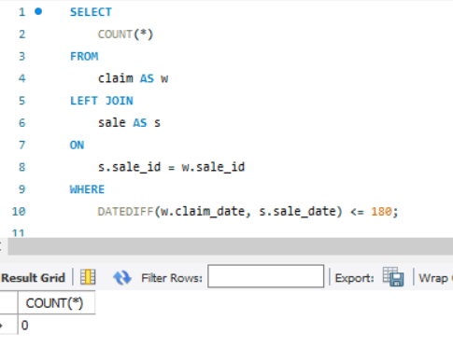

13. Determine how many warranty claims were filed for products launched in the last three years.

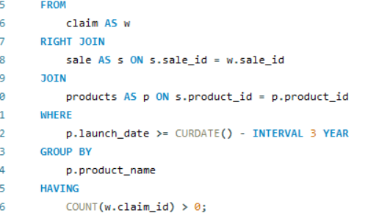

14. List the months in the last three years where sales exceeded 5,000 units in the USA

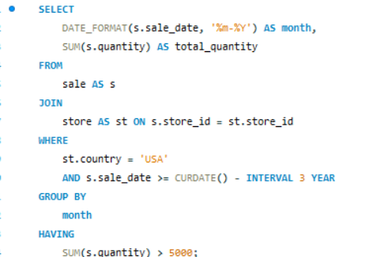

15. Identify the product category with the most warranty claims filed in the last two years.